Second Lieutenant Roy Duncanson
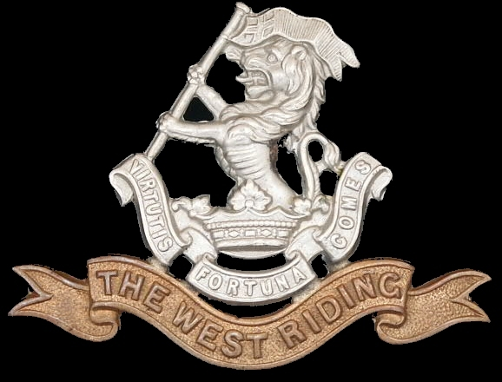
West Riding Regiment
West Riding Regiment
Army No:

Rank: Second Lieutenant
Date of Death: 07/07/1916
Regiment/Service: Duke of Wellington's (West Riding Regiment) 3rd Bn. attd. 9th Bn.
Panel Reference: Pier and Face 6 A and 6 B.
Memorial: THIEPVAL MEMORIAL

Thiepval Memorial

Each year a major ceremony is held at the memorial on 1 July
Visiting Information
The Panel numbers (or Pier and Face) quoted at the end of each entry relate to the panels dedicated to the Regiment served with. In some instances where a casualty is recorded as attached to another Regiment, his name may alternatively appear within their Regimental Panel (or Pier and Face). Please refer to the on-site Memorial Register Introduction to determine the alternative panel numbers (or Pier and Face) if you do not find the name within the quoted Panels (or Pier and Face).

Historical Information
On 1 July 1916, supported by a French attack to the south, thirteen divisions of Commonwealth forces launched an offensive on a line from north of Gommecourt to Maricourt. Despite a preliminary bombardment lasting seven days, the German defences were barely touched and the attack met unexpectedly fierce resistance. Losses were catastrophic and with only minimal advances on the southern flank, the initial attack was a failure. In the following weeks, huge resources of manpower and equipment were deployed in an attempt to exploit the modest successes of the first day. However, the German Army resisted tenaciously and repeated attacks and counter attacks meant a major battle for every village, copse and farmhouse gained. At the end of September, Thiepval was finally captured. The village had been an original objective of 1 July. Attacks north and east continued throughout October and into November in increasingly difficult weather conditions. The Battle of the Somme finally ended on 18 November with the onset of winter.
In the spring of 1917, the German forces fell back to their newly prepared defences, the Hindenburg Line, and there were no further significant engagements in the Somme sector until the Germans mounted their major offensive in March 1918.
The Thiepval Memorial, the Memorial to the Missing of the Somme, bears the names of more than 72,000 officers and men of the United Kingdom and South African forces who died in the Somme sector before 20 March 1918 and have no known grave. Over 90% of those commemorated died between July and November 1916. The memorial also serves as an Anglo-French Battle Memorial in recognition of the joint nature of the 1916 offensive and a small cemetery containing equal numbers of Commonwealth and French graves lies at the foot of the memorial.
The memorial, designed by Sir Edwin Lutyens, was built between 1928 and 1932 and unveiled by the Prince of Wales, in the presence of the President of France, on 1 August 1932 (originally scheduled for 16 May but due to the death of French President Doumer the ceremony was postponed until August).
The dead of other Commonwealth countries, who died on the Somme and have no known graves, are commemorated on national memorials elsewhere.

Roy Duncanson was Gazetted a second Lieutenant on 14th May 1915

1911 census for England
In 1911 Roy was staying with his parents at Langley Park Farm, Langley, Maidstone, Kent which goes some ways to explain why he joined an English Regiment. His father’s name was James Duncanson and he was 49 years of age in 1911. James’ occupation at this time was farmer. Roy’s mother was called Annie and she was 43 years of age. The eldest son was called Fergus and he was 21 years of age and an assistant farmer. Roy was next at 20 years of age and also an assistant farmer. Next in line was Una who was aged 18 years. The next sibling was Marjorie Duncanson who was 16 years old the next was Ian L Duncanson who was 15 years old and at school. The next child was a boy called Lindon T L Duncanson and he was 9 years 9 of age. The second last child was Jean C R Duncanson and she was 7 years old and lastly there was Patricia F A Duncanson who was 3 years old.

To support the mother there was a 20 year old girl called Margaret A Woodbus who acted as nurse and school maid.

