Second Lieutenant
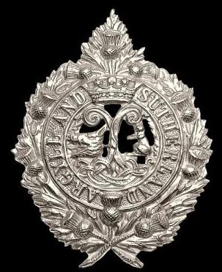
Argyle & Sutherland Highlanders
Robert Hood Brechin
1st Bn. Argyle and Sutherland Highlanders

Rank: Second Lieutenant
Date of Death: 30/09/1916
Age: 21
Regiment/Service: Seaforth Highlanders,
5th Bn. attd. 1st Bn.
Argyll and Sutherland Highlanders
Grave Reference: V. A. 5.
Cemetery: STRUMA MILITARY CEMETERY
Additional Information: Son of Mr. and Mrs. Robert H. Brechin, of Glasgow.

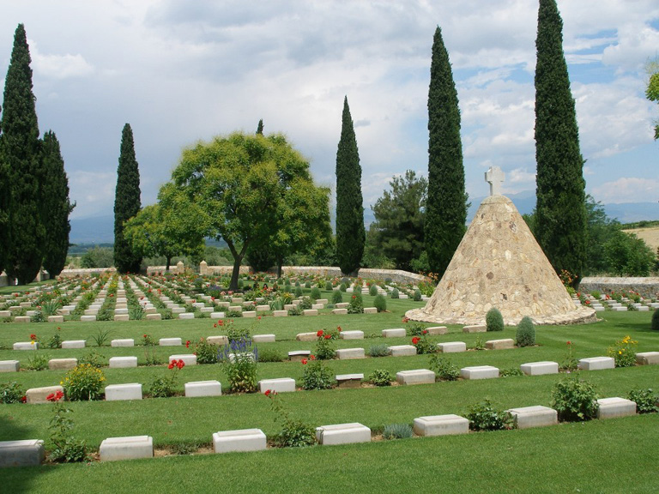
Struma Military Cemetery

Country: Greece
Identified Casualties: 896

Location Information
Note – Major road works are being undertaken along the E79 Thessaloniki, Serres Bulgaria road with no date of when this section of road shall be complete.
E79 is the main road between Thessaloniki and Serres/Bulgaria. Approximately 75km from Thessaloniki, take the exit marked Strimoniko, Kalokastro and Nigrita. Proceed for around 1 km until you reach the crossroads at Strimoniko. Turn left for Kalokastro and Nigrita and proceed for approximately 3 km until you come to the junction of Livadochori, Nigrita where the cemetery is signposted. Turn right onto the agricultural road and follow this for 400 metres and turn left for access to the cemetery.

Visiting Information
The Cemetery is permanently open and may be visited at any time.
For further information and enquiries please contact maoffice@cwgc.org

Historical Information
The Struma River flows through Bulgaria southward to the Greek frontier, then south-east into the Aegean Sea. From the Allied base at Salonika, a road ran north-east across the river to Seres, and it was this road that the right wing of the Allied army used for the movements of troops and supplies to the Struma front during the Salonika Campaign.
In the autumn of 1916, the 40th Casualty Clearing Station was established not far from the road near the 71 Kilometre stone and the cemetery made for it was originally called Kilo 71 Military Cemetery.
The original plot, Plot I, was set too close to a ravine and the graves in it were moved after the Armistice to the present plots VIII and IX. The remainder of the cemetery consists almost entirely of graves brought in from the battlefields, from the churchyards at Homondos, Haznatar and Kalendra, and from little front-line cemeteries (established by Field Ambulances or Battalions), of which the chief were those at Ormanli (24 burials), Dolab Wood (17 burials) and Big Tree Well (on the right bank of the Struma, opposite Ormanli; 17 burials).
Struma Military Cemetery contains 947 Commonwealth burials of the First World War, 51 of them unidentified. There are also 15 war graves of other nationalities.

1911 census
The 1911 census shows Robert Brechin staying with his parents at 40 Sherlnook Avenue, Pollockshields, they were living in a large house with 12 rooms with windows. Robert’s father was called Robert also and he was 62 years of age and a Flesher, employer. Robert’s father had been married for 24 years to 49 year old Jane. Jane had had 8 children over the years. Robert had a sister called Jane, aged 23, who was living with the family and a sister called Mary aged 17, also stayed with them. Robert was a 15 year old school pupil in 1911 and he had a 9 year old brother also living with the family at the time.

To help with the chores they had two servants, one was 20 year old Margaret Ryan who was a cook and domestic servant. The other was 19 year old Ellen Sweeney who was a 19 year old housemaid and domestic servant.

