Lance Corporal James Walter Paterson
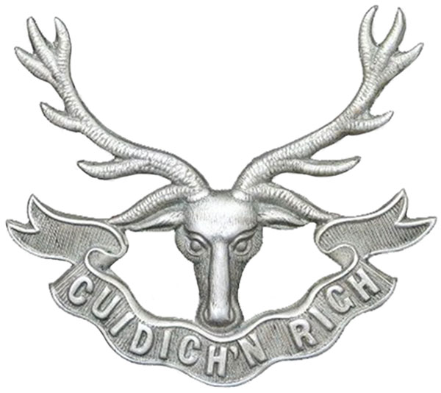
Seaforth Highlanders
Cap Badge
2nd Battalion Seaforth Highlanders
Army Number: S/21773

Rank: Lance Corporal
Service No: S/21773
Date of Death: 23/12/1917
Age: 24
Regiment/Service: Seaforth Highlanders, 2nd Bn.
Grave Reference: II. B. 2.
Cemetery: MONCHY BRITISH CEMETERY, MONCHY-LE-PREUX

Additional Information:
Son of James Paterson and Jeanie Buchanan Corbet Paterson, of 23, Onslow Drive, Dennistoun, Glasgow.

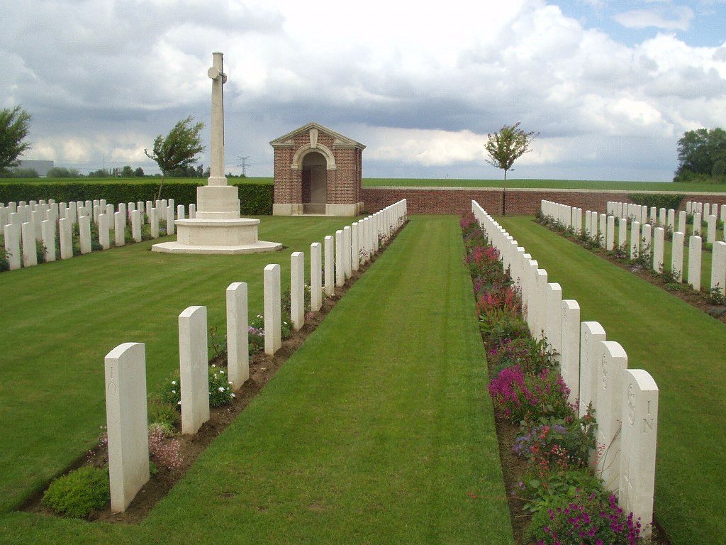
Monchy British Cemetery, Monchy-Le-Preux, France

Country: France
Locality: Pas de Calais
Identified Casualties: 523

Location Information
Monchy-le-Preux is a village in the department of the Pas-de-Calais on the north side of the main road (D33) from Arras to Cambrai. Monchy British Cemetery is nearly 2 kilometres west of the village down a 1 kilometre track.

Historical Information
Monchy village, a relatively high and commanding position, was captured by Commonwealth forces on 11 April 1917. The cemetery was begun at once and continued in use as a front-line cemetery until the German offensive of March 1918, when it fell into their hands. It was recaptured by the Canadian Corps on 26 August and used again for a month. The graves are very closely identified with the divisions which fought on this front.
There are now 581 Commonwealth servicemen of the First World War buried or commemorated in this cemetery. 58 of the burials are unidentified but there are special memorials to a number of casualties known to be buried among them.
The cemetery was designed by Sir Edwin Lutyens.

