Second Lieutenant James Hunter Lawrie
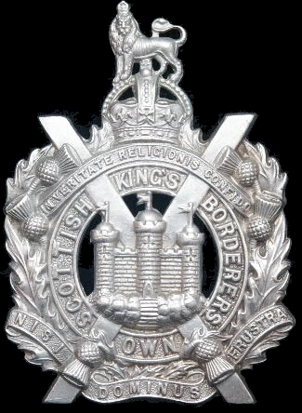
Kings Own Scottish Borderers
Cap Badge
3rd Battalion Kings Own Scottish Borderers

Rank: Second Lieutenant
Date of Death: 09/08/1916
Age: 20
Regiment/Service: King's Own Scottish Borderers, 3rd Bn. attd. 7th/8th Bn.
Grave Reference: I. D. 74.
Cemetery: DARTMOOR CEMETERY, BECORDEL-BECOURT

Additional Information:
Son of Ephraim S. and Margaret Lawrie, of 317, Onslow Drive, Dennistoun, Glasgow.

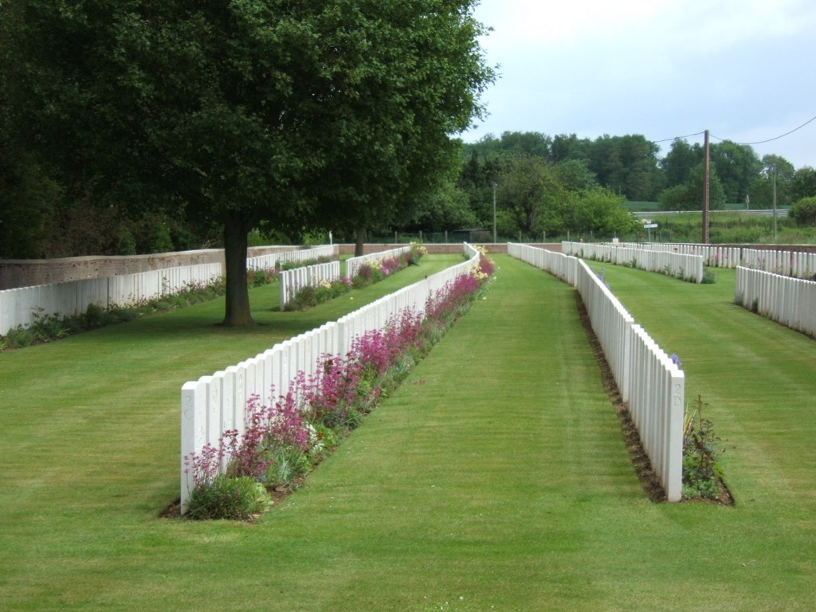
Dartmoor Cemetery, Becordel-Becourt, Somme, France

Country: France
Locality: Somme
Identified Casualties: 762

Location Information
Becordel-Becourt is a village about 2.5 kilometres south-east of Albert.
From the D938 (Albert-Peronne) take the road C2 (Becourt-Becordel). The Cemetery is immediately north of the village on the road to Becourt opposite the Communal Cemetery.

Historical Information
Dartmoor Cemetery was begun (as Becordel-Becourt Military Cemetery) in August 1915 and was used by the battalions holding that part of the line; its name was changed in May 1916 at the request of the 8th and 9th Battalions of the Devonshire Regiment. In September 1916, the XV Corps Main Dressing Station was established in the neighbourhood, but throughout 1917, the cemetery was scarcely used. It passed into German hands on 26 March 1918, but was retaken on 24 August by the 12th Division. There are five burials of August 1918, in Plot II, Row E.
In adjoining graves in Plot I, Row A, are buried a father and son, who served in the same artillery battery, and were killed in action on the same day.
Dartmoor Cemetery contains 768 Commonwealth burials of the First World War.
The cemetery was designed by Sir Edwin Lutyens.

Gazette
12th July 1915 ~ War. Office, 12th July, 1915. REGULAR FORCES.
SPECIAL RESERVE OF OFFICERS. INFANTRY. The undermentioned Cadets and ex-Cadets of the Officers Training Corps to be Second Lieutenants (on probation). Dated 12th July, 1915: - King's Own Scottish Borderers. James Hunter Lawrie, 3rd Battalion

28th February 1916 ~ on probation) are confirmed in their rank:- The King's Own Scottish Borderers. James Hunter Lawrie.

