Private Peter Rankine
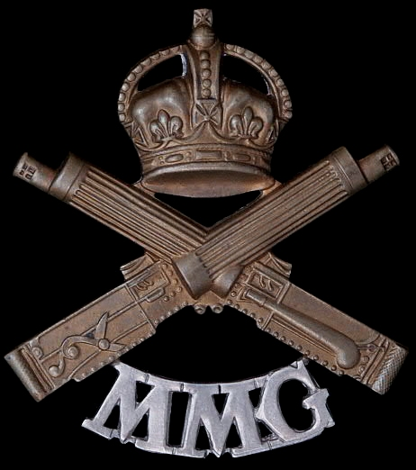
Machine Gun Corps
Machine Gun Corps
Army No: 66881

Rank: Private
Service No: 66881
Date of Death: 15/07/1917
Age: 28
Regiment/Service: Machine Gun Corps (Infantry), 35th Coy.
Grave Reference: I. A. 6.
Cemetery: MONCHY BRITISH CEMETERY, MONCHY-LE-PREUX
Additional Information:
Son of Henry and Isabella Rankin (nee Elliot), of 144, Craigpark, Glasgow.

Formerly: 17164, Argyle and Sutherland Highlanders

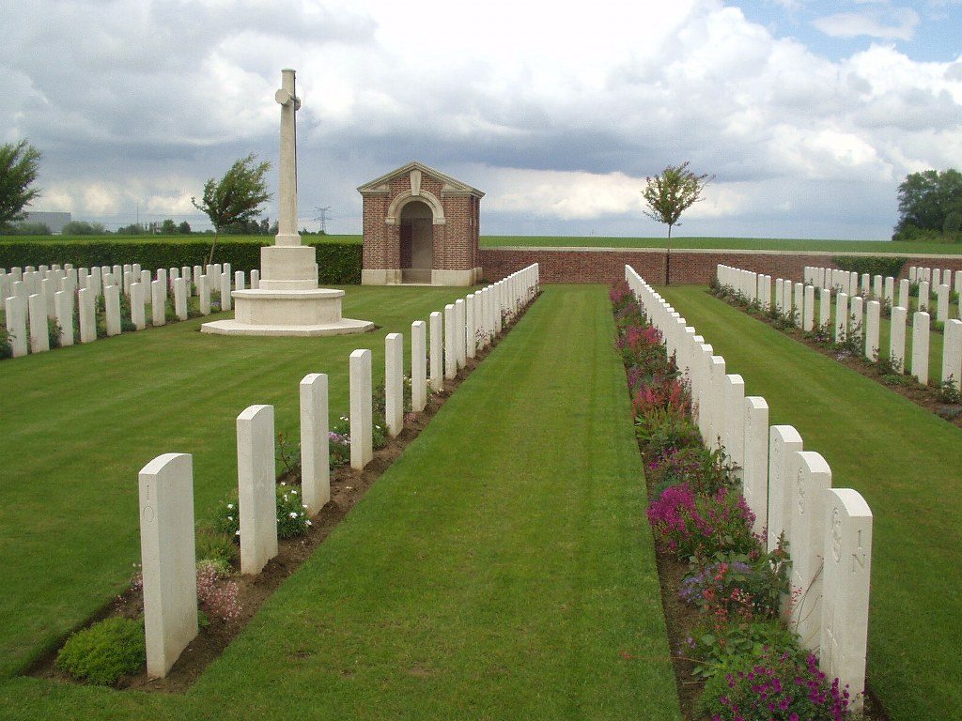
Monchy British Cemetery, Monchy-Le-Preux

Country: France
Locality: Pas de Calais
Identified Casualties: 523

Location Information
Monchy-le-Preux is a village in the department of the Pas-de-Calais on the north side of the main road (D33) from Arras to Cambrai. Monchy British Cemetery is nearly 2 kilometres west of the village down a 1 kilometre track.

Historical Information
Monchy village, a relatively high and commanding position, was captured by Commonwealth forces on 11 April 1917. The cemetery was begun at once and continued in use as a front-line cemetery until the German offensive of March 1918, when it fell into their hands. It was recaptured by the Canadian Corps on 26 August and used again for a month. The graves are very closely identified with the divisions which fought on this front.
There are now 581 Commonwealth servicemen of the First World War buried or commemorated in this cemetery. 58 of the burials are unidentified but there are special memorials to a number of casualties known to be buried among them.
The cemetery was designed by Sir Edwin Lutyens.

1911 census
The 1911 census shows Peter Rankine residing at 144 Craigpark, Springburn, Glasgow which had 4 rooms with windows. Peter’s father was 50 year old Henry Rankine, Flesher who employed staff and he had been married to his 48 year old wife Isabella, of 22 years. Isabella had delivered 6 children and only four survived in 1911. Peter was 22 years of age and also a Flesher. Peter’s brother was an apprentice locomotive engineer and he was 20 years of age. Henry was next and he was 15 years of age and employed as a Warehouseman in Drapers. The last son was called Andrew and he was 12 years old and a school pupil.

