Sergeant Matthew Barr Macnaughton
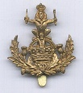
Queens Own Glasgow Yeomanry
Queens Own Glasgow Yeomanry
Army No: 1479

Rank: Sergeant
Service No: 1479
Date of Death: 19/02/1916
Age: 31
Regiment/Service: Glasgow Yeomanry (Queen's Own Royal)
Grave Reference: I. G. 23.
Cemetery: MENIN ROAD SOUTH MILITARY CEMETERY

Mentioned in Dispatches on: 15th September 1915. Died in Franc/Flanders

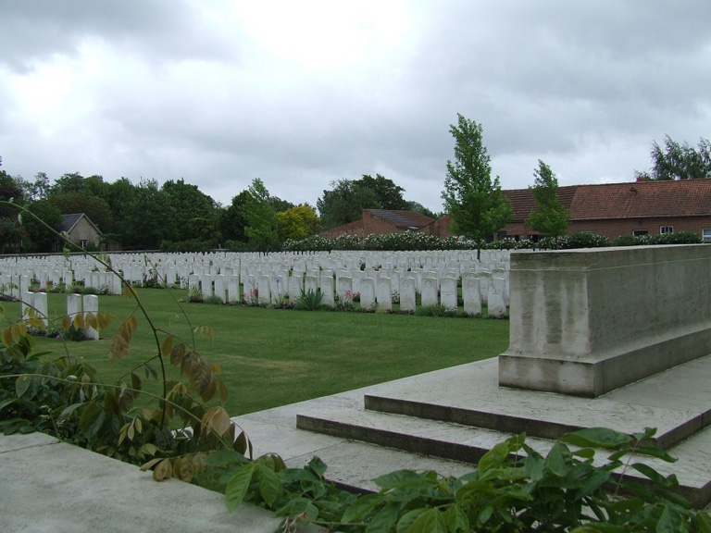
Menin Road South Military Cemetery

Country: Belgium
Locality: West-Vlaanderen
Identified Casualties: 1538

Location Information
Menin Road South Military Cemetery is located 2 Kms east of Ieper town centre, on the Meenseweg (N8), connecting Ieper to Menen.

From Ieper town centre the Meenseweg is located via Torhoutstraat and right onto Basculestraat. Basculestraat ends at a main crossroads, directly over which begins the Meenseweg. The Cemetery is located 800 metres along the Meenseweg on the right hand side of the road.

Visiting Information
Wheelchair access to site possible, but may be by an alternative entrance. For further information regarding wheelchair access, please contact our Enquiries Section on telephone number: 01628 507200

Historical Information
The Menin Road ran east and a little south from Ypres (now Ieper) to a front line which varied only a few kilometres during the greater part of the war. The position of this cemetery was always within the Allied lines. It was first used in January 1916 by the 8th South Staffords and the 9th East Surreys, and it continued to be used by units and Field Ambulances until the summer of 1918. The cemetery was increased after the Armistice when graves were brought in from isolated positions on the battlefields to the east and the following cemetery:-

MENIN ROAD NORTH MILITARY CEMETERY was on the North side of the road at almost the same point. It was used by the units and Field Ambulances of another Corps from May, 1915, to August, 1916, and again to a small extent in 1917 and 1918. It contained the graves of 130 soldiers from the United Kingdom, three from Canada, and three from Newfoundland.

There are now 1,657 servicemen of the First World War buried or commemorated in this cemetery. 119 of the burials are unidentified but special memorials are erected to 24 casualties known or believed to be buried among them. In addition, there are special memorials to 54 casualties who were buried in Menin Road North Military Cemetery, whose graves were probably destroyed by shell fire and could not be found. These are numbered between 1 and 57.

The cemetery was designed by Sir Reginald Blomfield.

Army records show Matthew’s home address as Dennistown, Glasgow

The 1901 census shows Matthew Barr Macnaughton at 143 Onslow Drive, Springburn with his father, (Henry Macnaughton, ironmonger aged 48) and his mother Alice Macnaughton aged 49 years. Also staying in the house were his brother Henry Macnaughton aged 21, who was listed as an ironmonger’s assistant. His elder sister Jessie Macnaughton, aged 18 was listed as a bookkeeper, next was second youngest Matthew B Macnaughton aged 15 and a scholar. Lastly we have the youngest brother, 12 year old Douglas Macnaughton, also a scholar.

