Private Robert Young
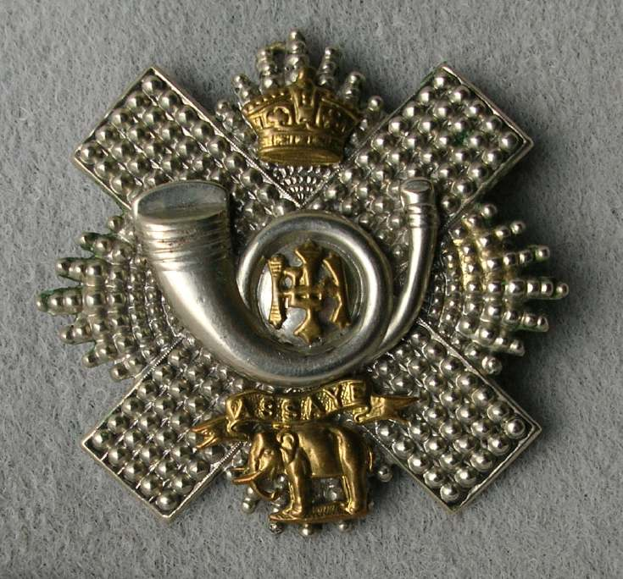
Highland Light Infantry
Cap Badge
17th Highland Light Infantry
Army Number: 15475

Rank: Private
Service No: 15475
Date of Death: 01/07/1916
Age: 26
Regiment/Service: Highland Light Infantry, 17th Bn.
Panel Reference: Pier and Face 15 C.
Memorial: THIEPVAL MEMORIAL

Additional Information:
Son of Janet Young, of 30, Berelands Rd., Prestwick, Ayrshire, and the late James Young.

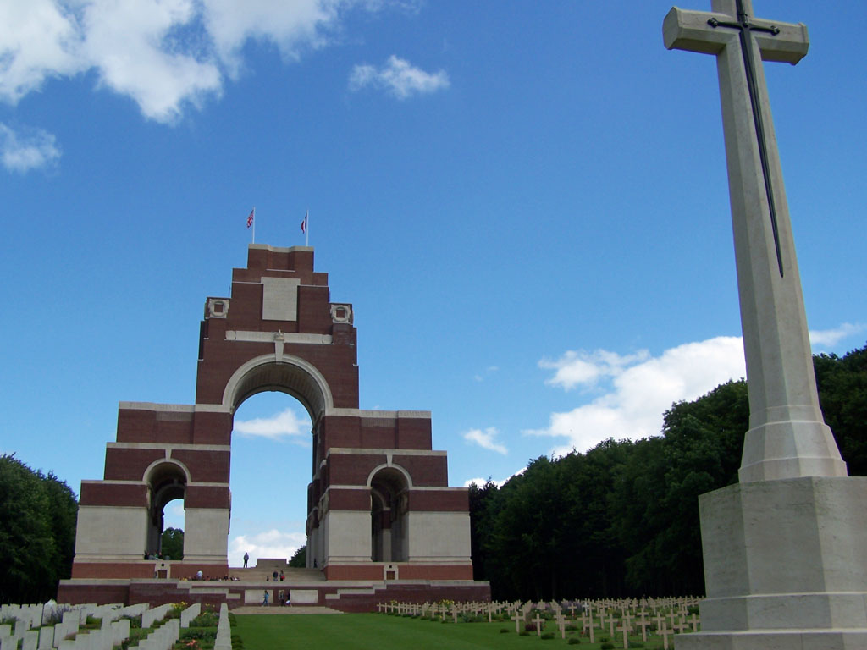
Thiepval Memorial, Somme, France

Country: France
Locality: Somme
Identified Casualties: 72195

Location Information
The Thiepval Memorial will be found on the D73, next to the village of Thiepval, off the main Bapaume to Albert road (D929).
Each year a major ceremony is held at the memorial on 1 July

Visiting Information
The Panel numbers (or Pier and Face) quoted at the end of each entry relate to the panels dedicated to the Regiment served with. In some instances where a casualty is recorded as attached to another Regiment, his name may alternatively appear within their Regimental Panel (or Pier and Face). Please refer to the on-site Memorial Register Introduction to determine the alternative panel numbers (or Pier and Face) if you do not find the name within the quoted Panels (or Pier and Face).

Historical Information
On 1 July 1916, supported by a French attack to the south, thirteen divisions of Commonwealth forces launched an offensive on a line from north of Gommecourt to Maricourt. Despite a preliminary bombardment lasting seven days, the German defences were barely touched and the attack met unexpectedly fierce resistance. Losses were catastrophic and with only minimal advances on the southern flank, the initial attack was a failure. In the following weeks, huge resources of manpower and equipment were deployed in an attempt to exploit the modest successes of the first day. However, the German Army resisted tenaciously and repeated attacks and counter attacks meant a major battle for every village, copse and farmhouse gained. At the end of September, Thiepval was finally captured. The village had been an original objective of 1 July. Attacks north and east continued throughout October and into November in increasingly difficult weather conditions. The Battle of the Somme finally ended on 18 November with the onset of winter.
In the spring of 1917, the German forces fell back to their newly prepared defences, the Hindenburg Line, and there were no further significant engagements in the Somme sector until the Germans mounted their major offensive in March 1918.
The Thiepval Memorial, the Memorial to the Missing of the Somme, bears the names of more than 72,000 officers and men of the United Kingdom and South African forces who died in the Somme sector before 20 March 1918 and have no known grave. Over 90% of those commemorated died between July and November 1916. The memorial also serves as an Anglo-French Battle Memorial in recognition of the joint nature of the 1916 offensive and a small cemetery containing equal numbers of Commonwealth and French graves lies at the foot of the memorial.
The memorial, designed by Sir Edwin Lutyens, was built between 1928 and 1932 and unveiled by the Prince of Wales, in the presence of the President of France, on 1 August 1932 (originally scheduled for 16 May but due to the death of French President Doumer the ceremony was postponed until August).
The dead of other Commonwealth countries, who died on the Somme and have no known graves, are commemorated on national memorials elsewhere.

