Private Douglas Fairley McGregor
5th Battalion Cameronian (Scottish Rifles)
Army Number: 7305

Rank: Private
Service No: 7305
Date of Death: 29/10/1916
Age: 20
Regiment/Service: Cameronians (Scottish Rifles), 5th Bn.
Grave Reference: V. G. 34.
Cemetery: CATERPILLAR VALLEY CEMETERY, LONGUEVAL

Additional Information:
Son of David and Jessie McGregor, of 33, Camphill St., Queen's Park, Glasgow.

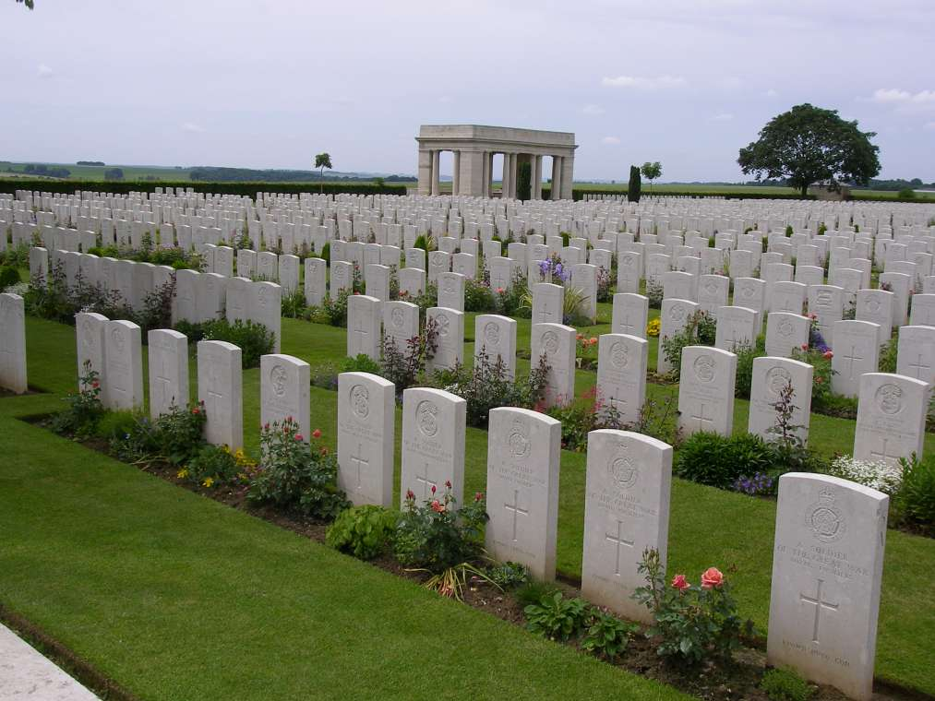
Caterpillar Valley Cemetery, Longueval, Somme, France

Country: France
Locality: Somme
Identified Casualties: 1773

Location Information
Longueval is a village approximately 13 kilometres east of Albert and 10 kilometres south of Bapaume.
Caterpillar Valley Cemetery lies a short distance west of Longueval on the south side of the road to Contalmaison.

Historical Information
Caterpillar Valley was the name given by the army to the long valley which rises eastwards, past "Caterpillar Wood", to the high ground at Guillemont.
The ground was captured, after very fierce fighting, in the latter part of July 1916. It was lost in the German advance of March 1918 and recovered by the 38th (Welsh) Division on 28 August 1918, when a little cemetery was made (now Plot 1 of this cemetery) containing 25 graves of the 38th Division and the 6th Dragoon Guards. After the Armistice, this cemetery was hugely increased when the graves of more than 5,500 officers and men were brought in from other small cemeteries, and the battlefields of the Somme. The great majority of these soldiers died in the autumn of 1916 and almost all the rest in August or September 1918.
Of the burial grounds from which Commonwealth graves were taken to Caterpillar Valley Cemetery:-
CLARK's DUMP CEMETERY, BAZENTIN, was a little West of High Wood, on the road from Bazentin-le-Petit to Flers. It contained the graves of 26 soldiers from the United Kingdom, and two from South Africa, who fell in August-December, 1916.
GINCHY GERMAN CEMETERY (500 metres North of the village, between the Flers and Lesboeufs roads), in which two unknown British soldiers were buried.
McCORMICK's POST CEMETERY, FLERS, nearly two kilometres West of Flers village. Here were buried 19 soldiers from the United Kingdom, nine from Australia and nine from New Zealand, who fell in September-November, 1916.
MARTINPUICH ROAD CEMETERY, BAZENTIN, contained the graves of 41 soldiers from the United Kingdom who fell in July and August, 1916.
SNOWDON CEMETERY, BAZENTIN, in Bazentin-le-Grand village, contained the graves of 24 soldiers of the 38th (Welsh) Division who fell in August and September, 1918.
WELSH CEMETERY, LONGUEVAL, between Flers village and High Wood, in which were buried 17 soldiers of the 38th (Welsh) Division who fell in August and September, 1918.
CATERPILLAR VALLEY CEMETERY now contains 5,569 Commonwealth burials and commemorations of the First World War. 3,796 of the burials are unidentified but there are special memorials to 32 casualties known or believed to be buried among them, and to three buried in McCormick's Post Cemetery whose graves were destroyed by shell fire.
On the 6th November 2004, the remains of an unidentified New Zealand soldier were removed from this cemetery and entrusted to New Zealand at a ceremony held at the Longueval Memorial, France. The remains had been exhumed by staff of the Commonwealth War Graves Commission from Plot 14, Row A, Grave 27 and were later laid to rest within the Tomb of the Unknown Warrior, at the National War Memorial, Wellington, New Zealand.
On the east side of the cemetery is the CATERPILLAR VALLEY (NEW ZEALAND) MEMORIAL, commemorating more than 1,200 officers and men of the New Zealand Division who died in the Battles of the Somme in 1916, and whose graves are not known.
This is one of seven memorials in France and Belgium to those New Zealand soldiers who died on the Western Front and whose graves are not known. The memorials are all in cemeteries chosen as appropriate to the fighting in which the men died.
Both cemetery and memorial were designed by Sir Herbert Baker.

