Corporal Robert L Haldane
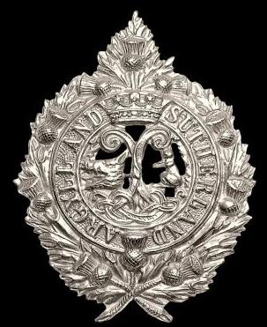
Argyle & Sutherland Highlanders
12th Bn. Argyle & Sutherland Highlanders
Army No: 203200

Rank: Corporal
Service No: 203200
Date of Death: 19/09/1918
Age: 29
Regiment/Service: Argyll and Sutherland Highlanders, 12th Bn.
Grave Reference: V. D. 33.
Cemetery: DOIRAN MILITARY CEMETERY

Additional Information:
Son of Andrew and Mary Haldane, of 828, West 10th St., Los Angeles, California, U.S.A. Native of Glasgow, Scotland.

Robert had previously been a member of 231, R.A.M.C.

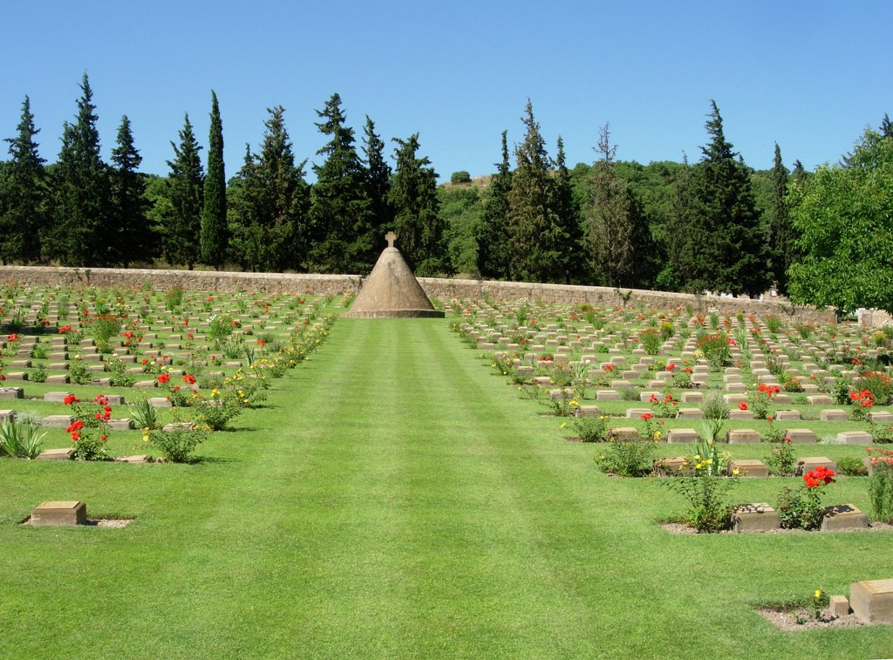
Doiran Military Cemetery

Country: Greece
Identified Casualties: 889

Location Information
Doiran Military Cemetery is situated in the north of Greece close to the Macedonia border and near the south-east shore of Lake Doiran. It is approximately 2 kilometres north west of Drossato village behind and to the west of Doirani village and is reached via a farm track.
From Thessaloniki take the Thessaloniki – Kilkis National Road north for approximately 70 km following the directions for the town of Kilkis until you come to a crossroads with the town of Drossato on your right. Turn left at this crossroad following the signs for Doirani Village/Lake and Customs. Continue on this road for approximately 2 km where you shall pick up the CWGC signs on the outskirts of the village that shall lead you around the village of Doirani and to the cemetery.
The Doiran Memorial, is on what was called Colonial Hill, it can be seen from a distance and is clearly signposted.

Visiting Information
The Cemetery is permanently open and may be visited at any time.
For further information and enquiries please contact maoffice@cwgc.org

Historical Information
The cemetery (originally known as Colonial Hill Cemetery No.2) was formed at the end of 1916 as a cemetery for the Doiran front. The graves are almost entirely those of officers and men of the 22nd and 26th Divisions and largely reflect the fighting of April and May 1917 (the attacks on the Petit-Couronne), and 18-19 September 1918 (the attacks on Pip Ridge and the Grand-Couronne). In October and November 1918, after the final advance, a few burials took place from the 25th Casualty Clearing Station.
After the Armistice, graves were brought into the cemetery from the battlefields and from by some small burial grounds, the most important of which was Strumnitza British Military Cemetery, north-west of Doiran, made by the 40th Casualty Clearing Station in October and November 1918.
DOIRAN MILITARY CEMETERY now contains 1,338 Commonwealth burials of the First World War, 449 of them unidentified. There are also one French and 45 Greek war graves.
The DOIRAN MEMORIAL, which stands near the cemetery, serves the dual purpose of Battle Memorial of the British Salonika Force (for which a large sum of money was subscribed by the officers and men of that force), and place of commemoration for more than 2,000 Commonwealth servicemen who died in Macedonia and whose graves are not known.
The memorial was designed by Sir Robert Lorimer with sculpture by Walter Gilbert.

1911 census
Robert Haldane was 20 years of age in 1911 and at the time he was working as a dead meat salesman. He was residing at 8 Granville Street, Woodside, Glasgow along with his father Andrew Haldane, aged 61 and a Flesher employer. His mother, Mary aged 51 years, who had been married for 26 years and had delivered 5 children, all of whom were living in 1911.

Only 4 of the 5 children were staying in the family home and the eldest there was Joseph G Haldane, aged 23 years and he was employed as an assistant draper. The next eldest was Margaret J Haldane, aged 17 years and who was employed as a Post Office Assistant. The last sibling in the family home was Douglas W Haldane, aged 14 years and a school pupil.

The home had 7 rooms with windows.

